**Building A Face Detection App on AWS**

|  |
| --- |
| * NAME – PRAGATI NAIKARE * [**EMAIL – pragatinaikare@gmail.com**](mailto:EMAIL%20-%20pragatinaikare@gmail.com) * CONTACT NO -8668285886 * COLLEGE NAME – DR DY PATIL INSTITUTE OF ENGINEERING MANAGEMENT AND RESEARCH, Akurdi , Pune 411033 |

**\*I have attached all screenshot below**

**1.AWS**

**1.1AWS Login screen with username**

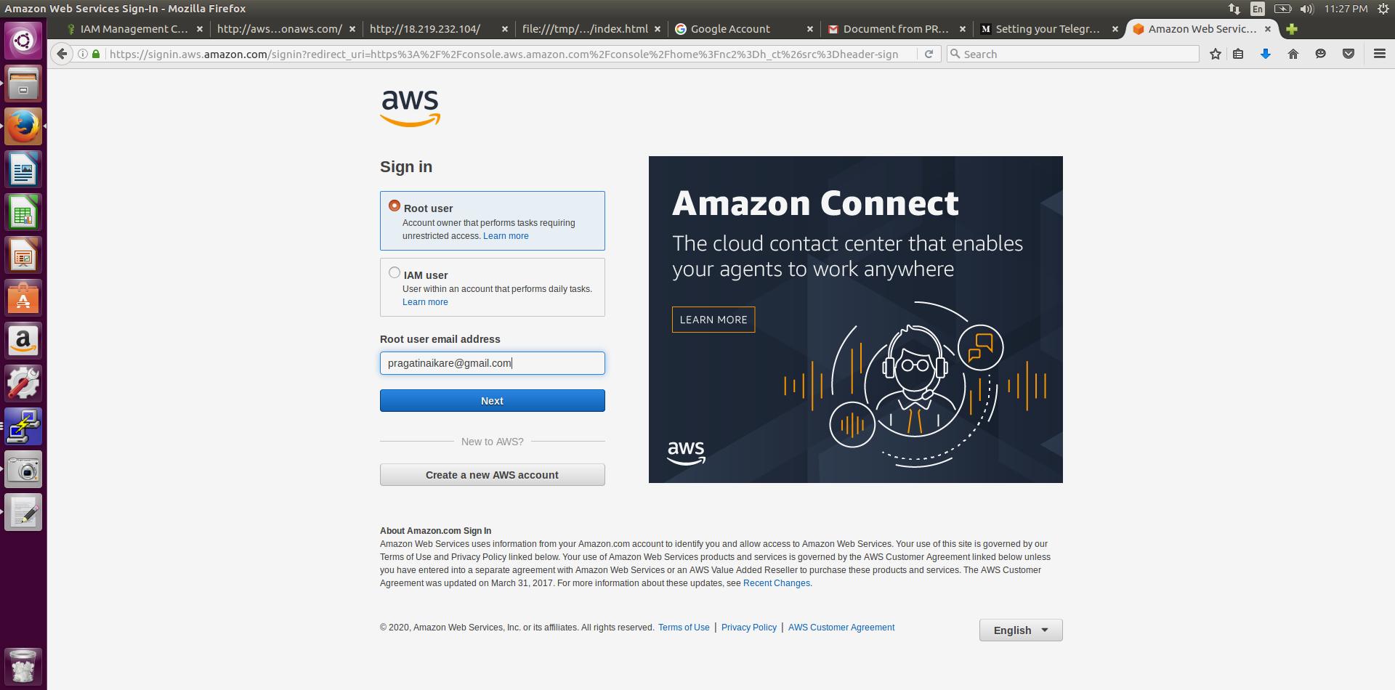

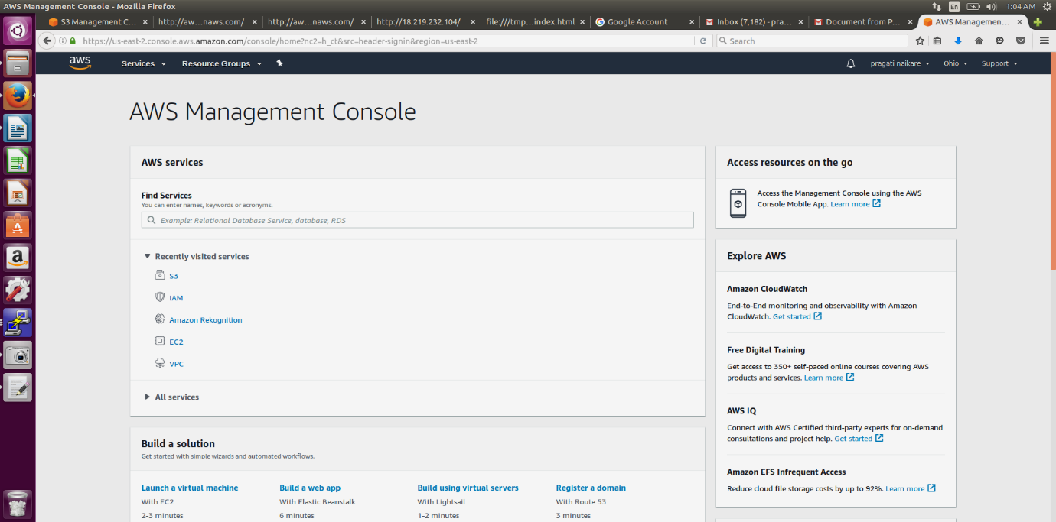

**1.2 EC2 Dashboard**

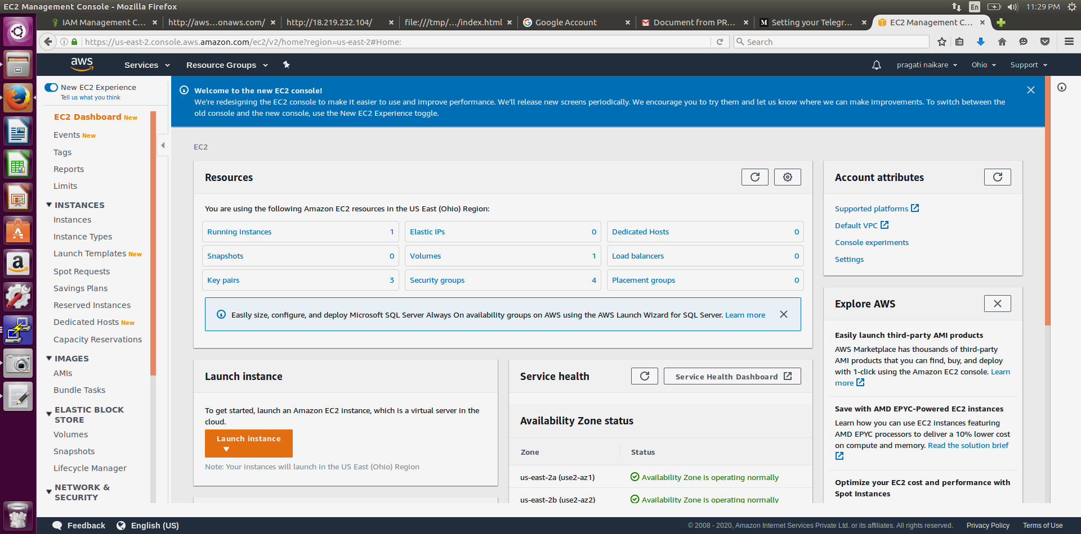

**1.3 S3 Dashboard**

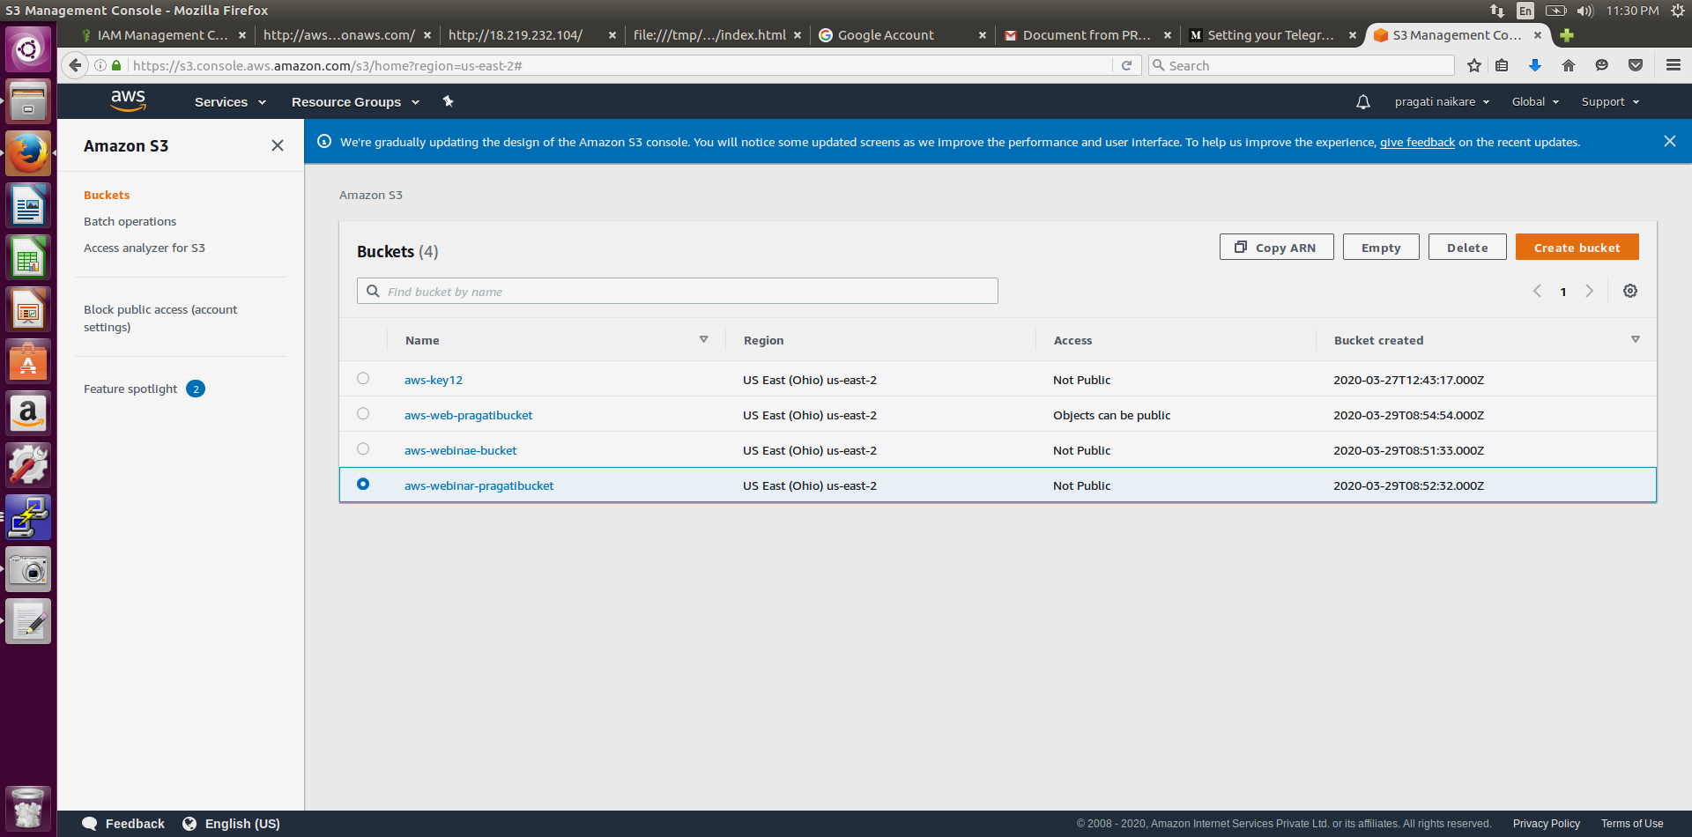

**1.4 Rekognition Dashboard**

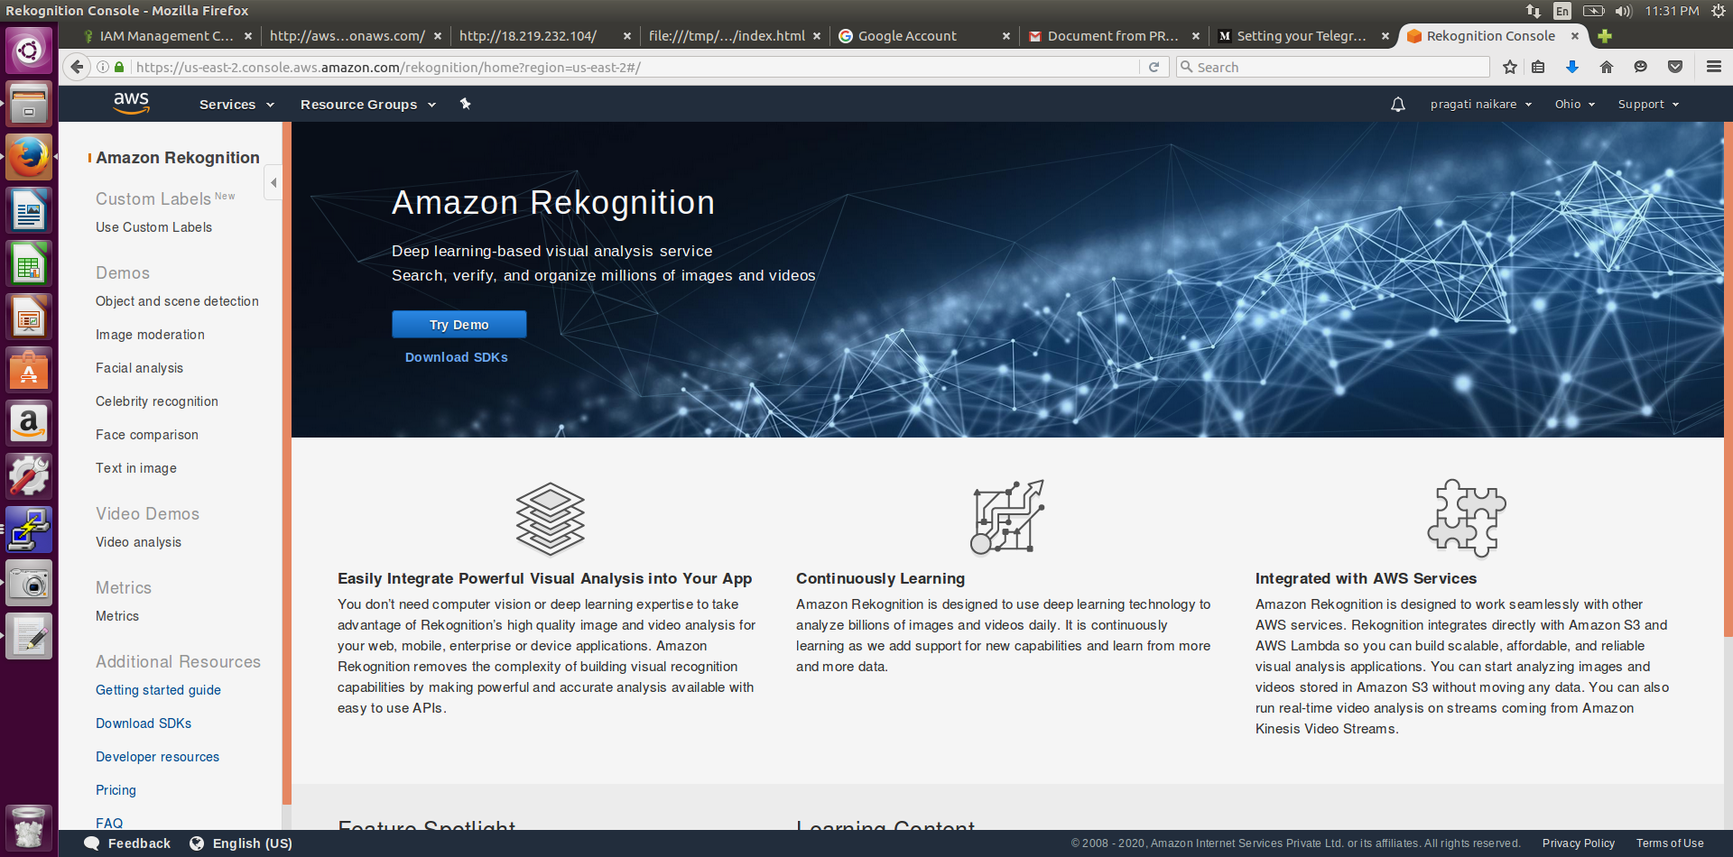

**2. EC2**

**2.1 Choosing an AMI**

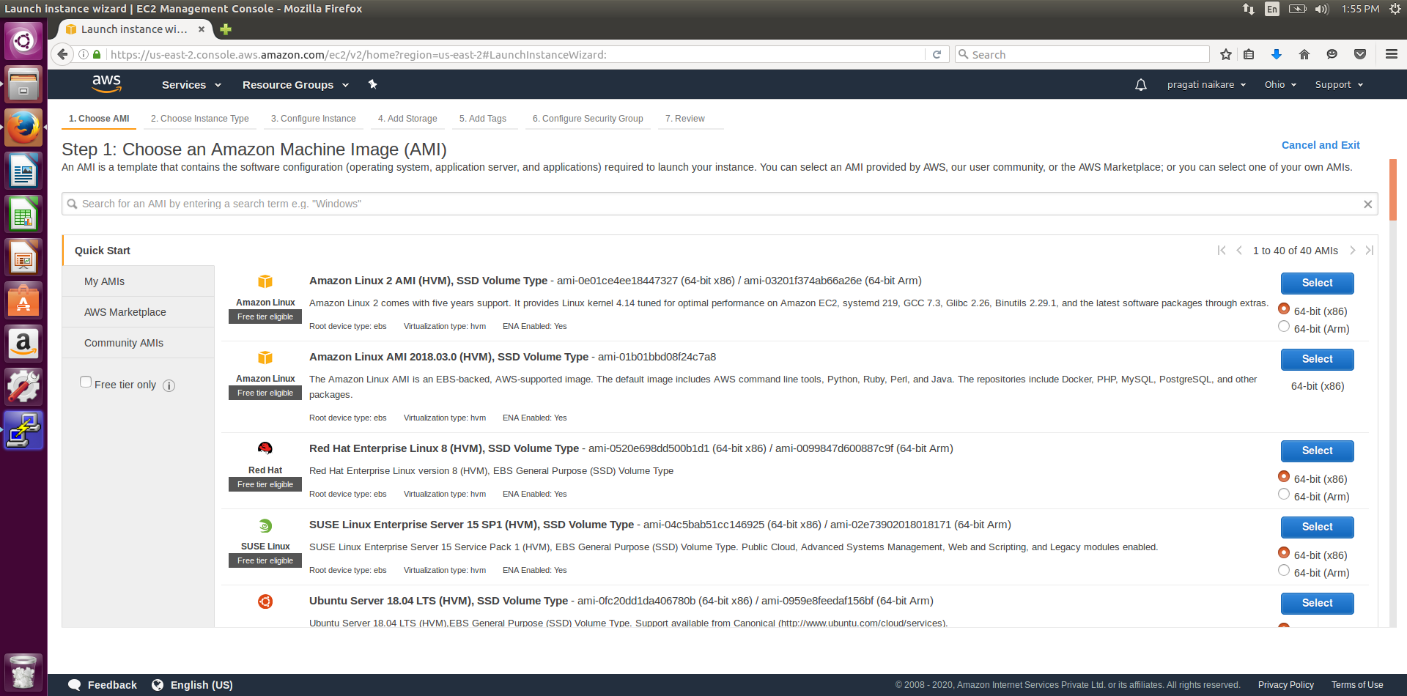

**2.2Choosing An Instance Type**

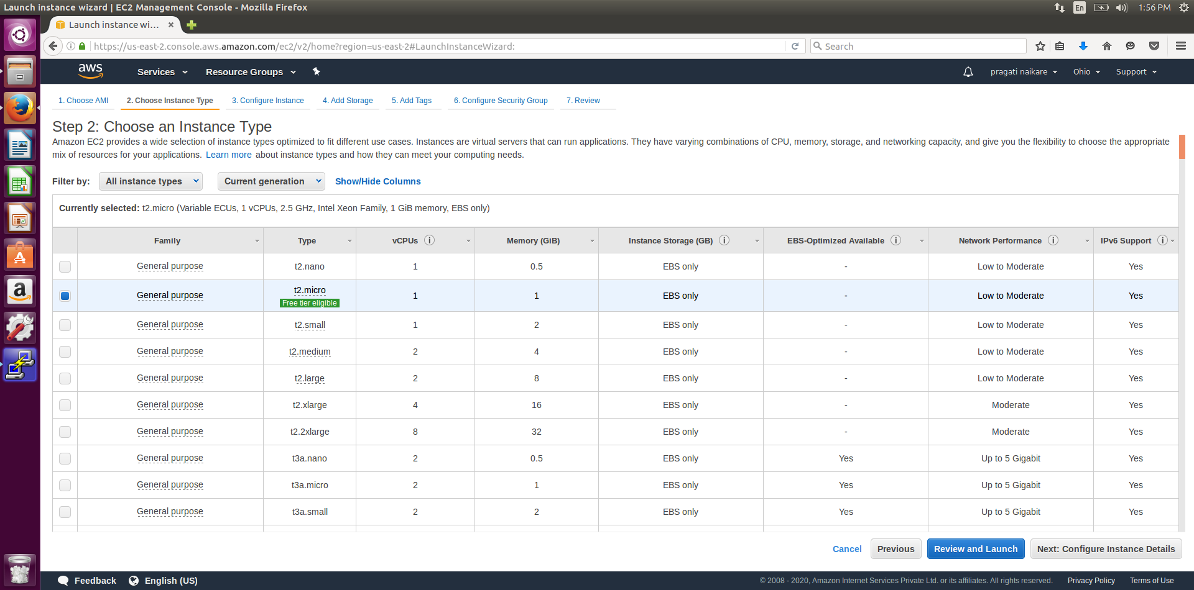

**2.3 Adding Storage**

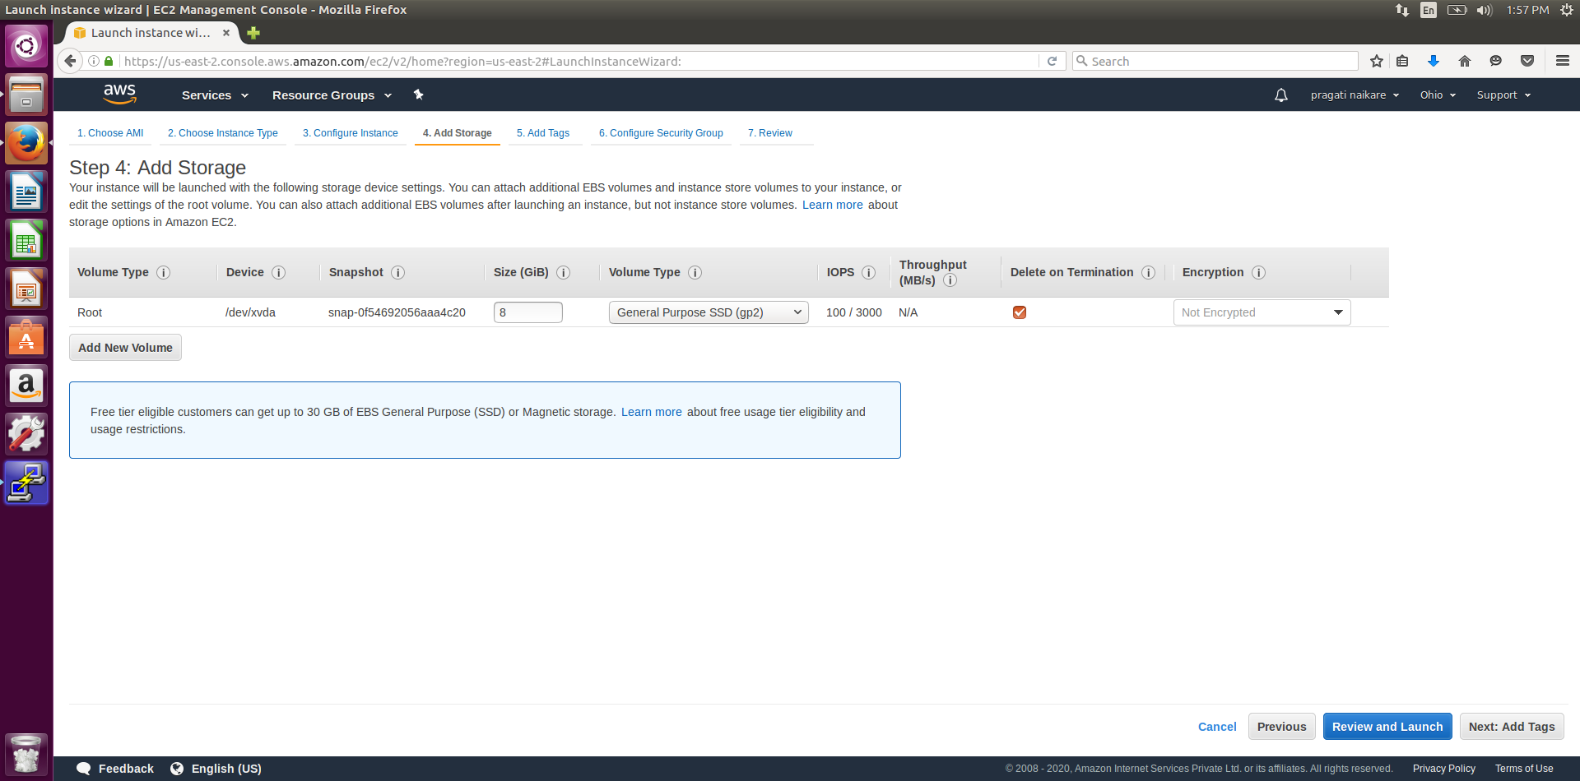

**2.4 Configuring Security Group**

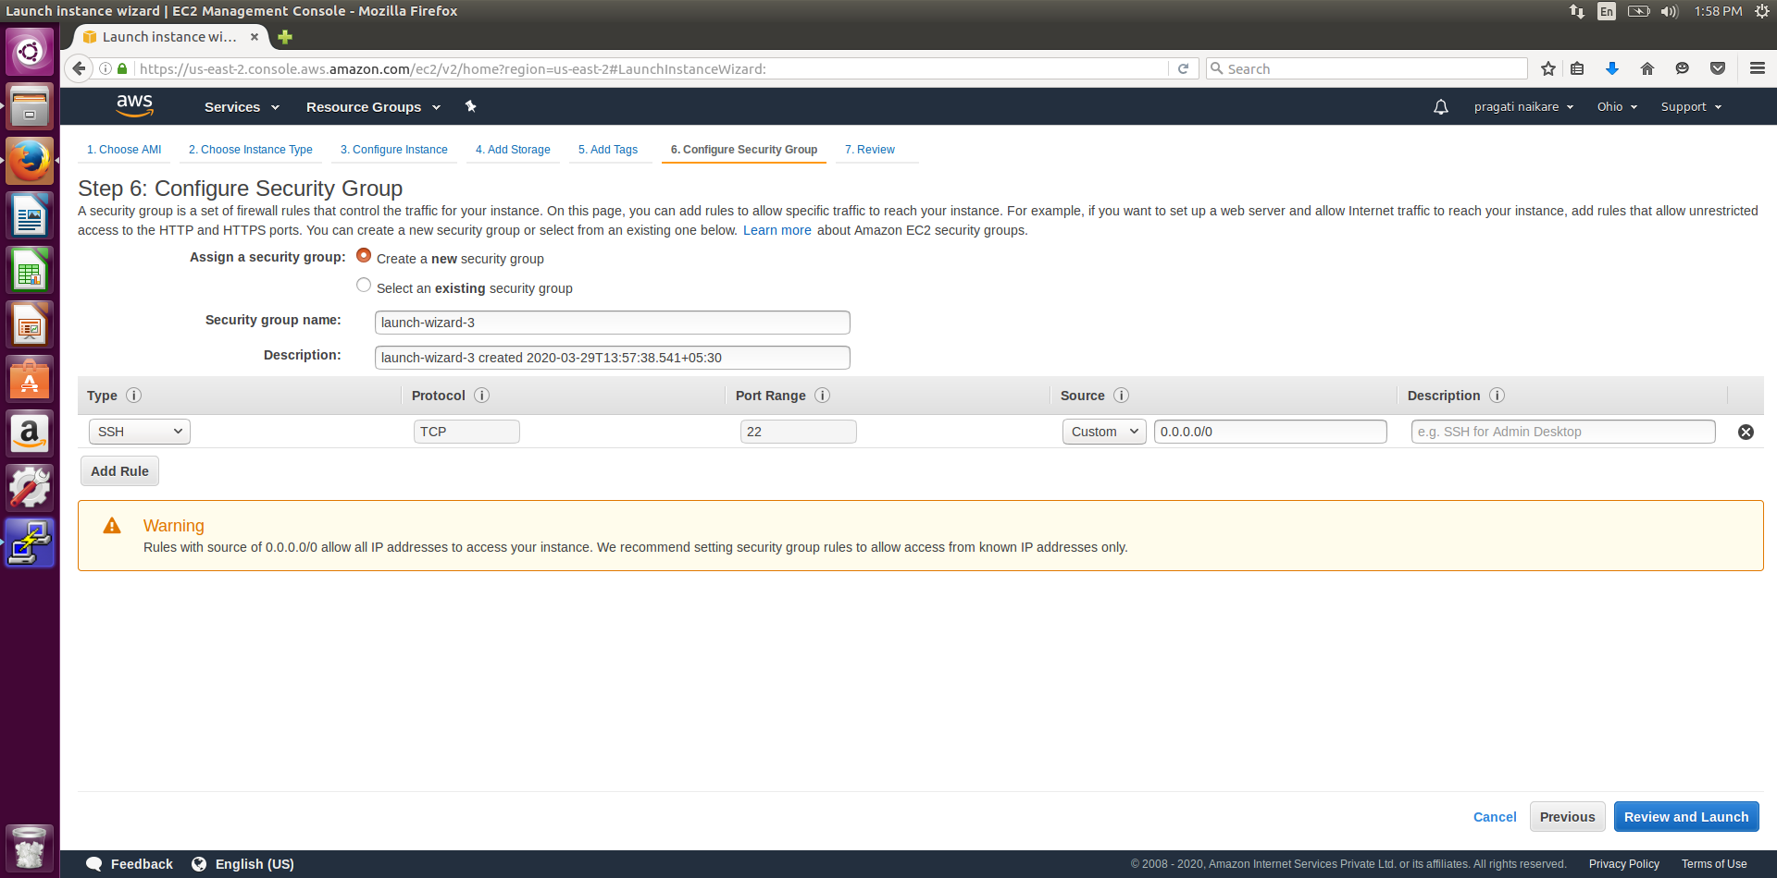

**2.5 Key Pair Download**

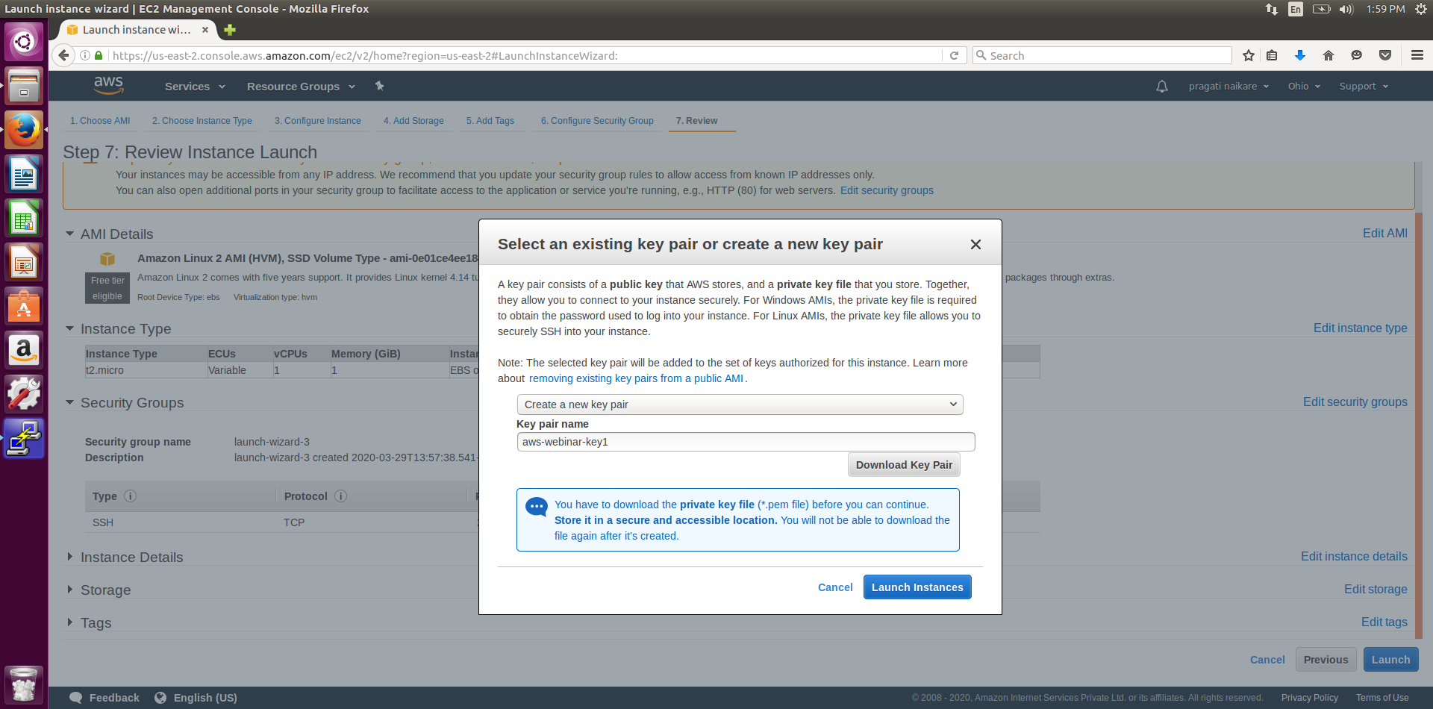

**2.6 Puttygen conversion from pem to ppk**

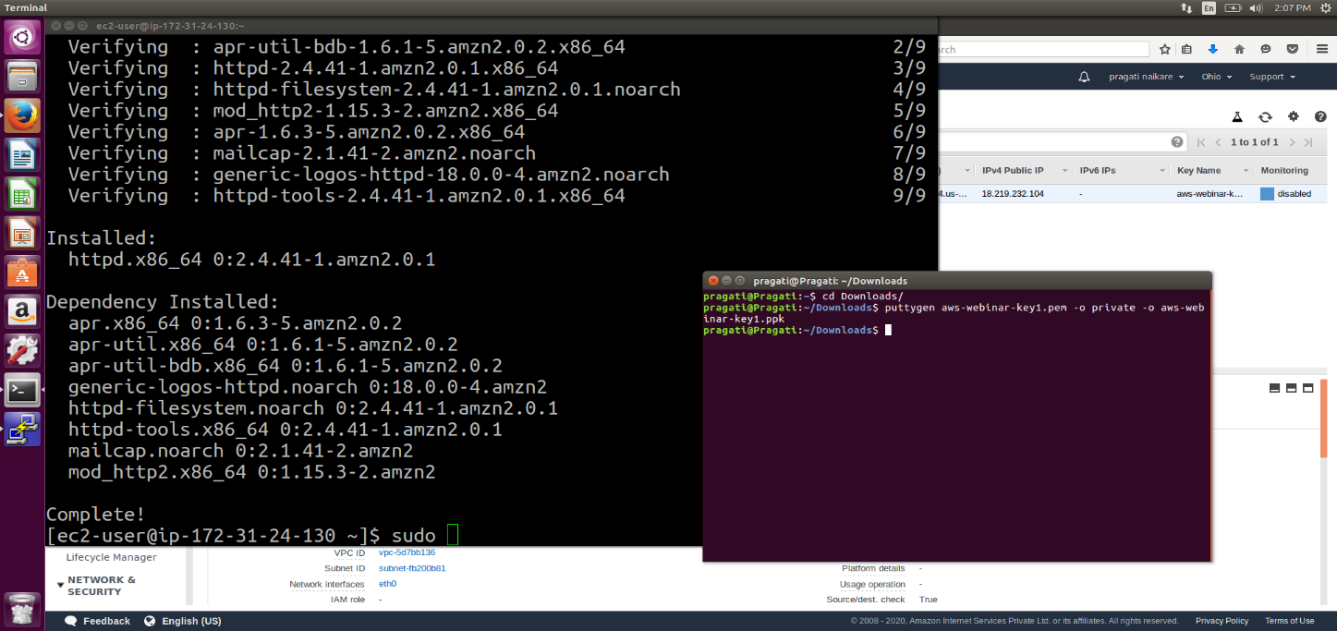

**2.7 Logged in EC2 black screen**

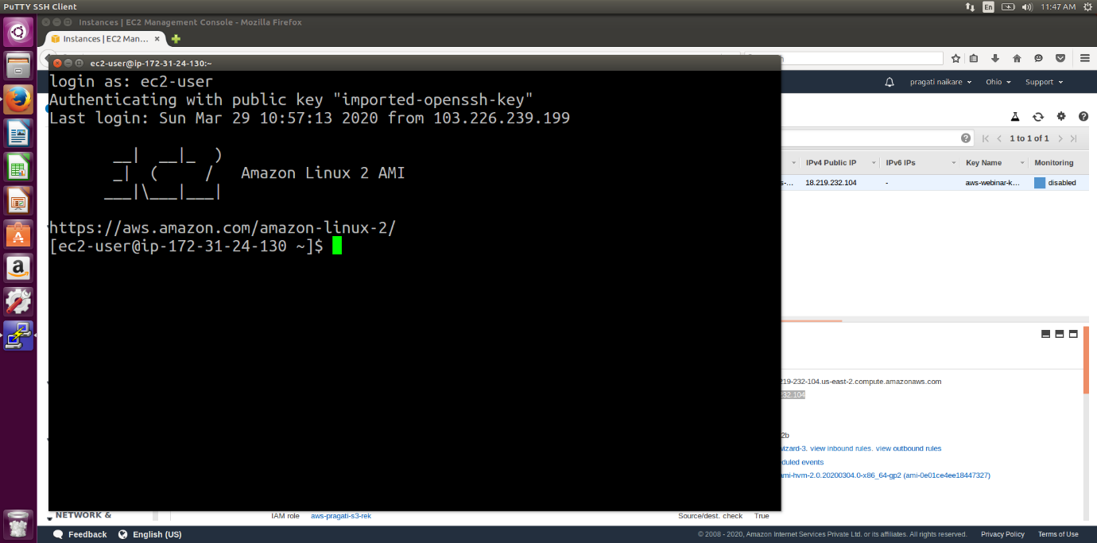

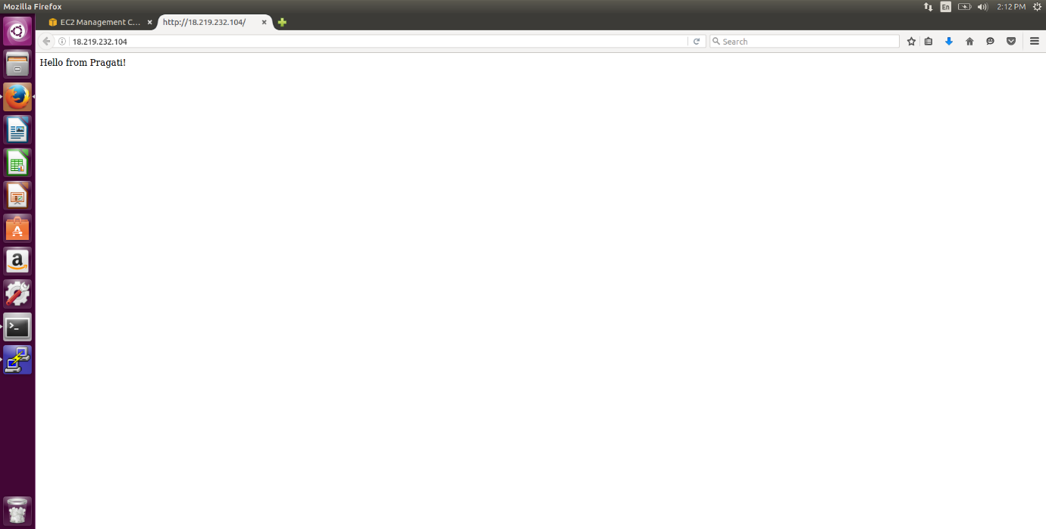

**3. S3**

**3.1 Creating a bucket**

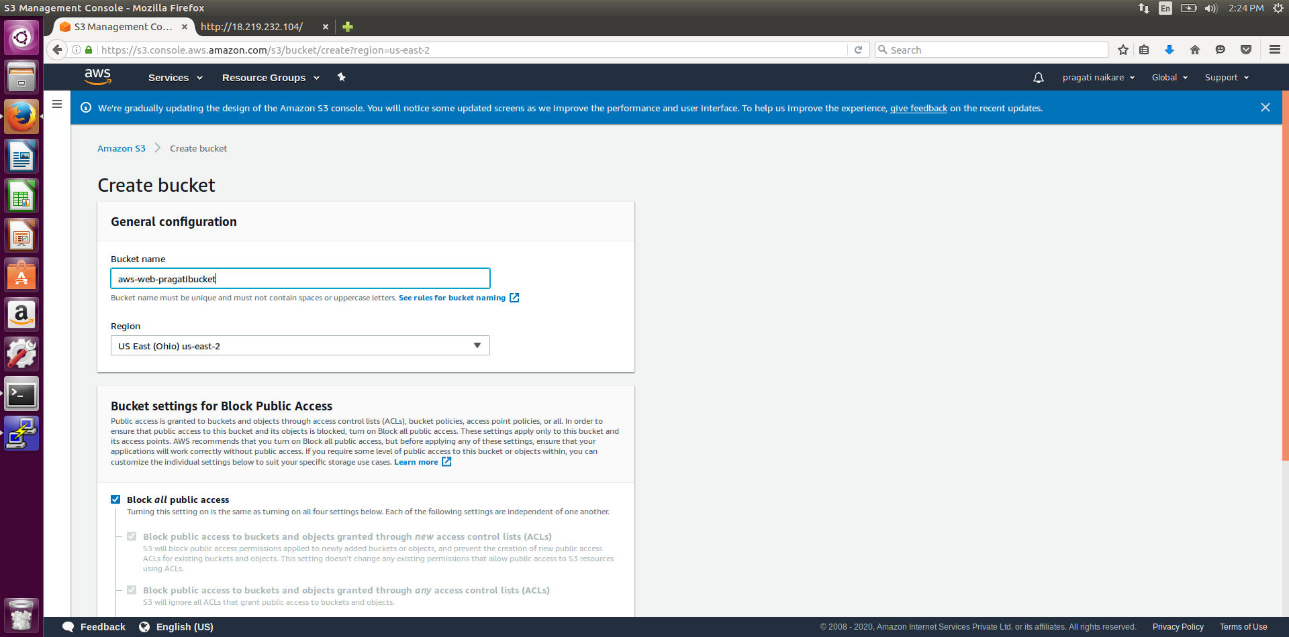

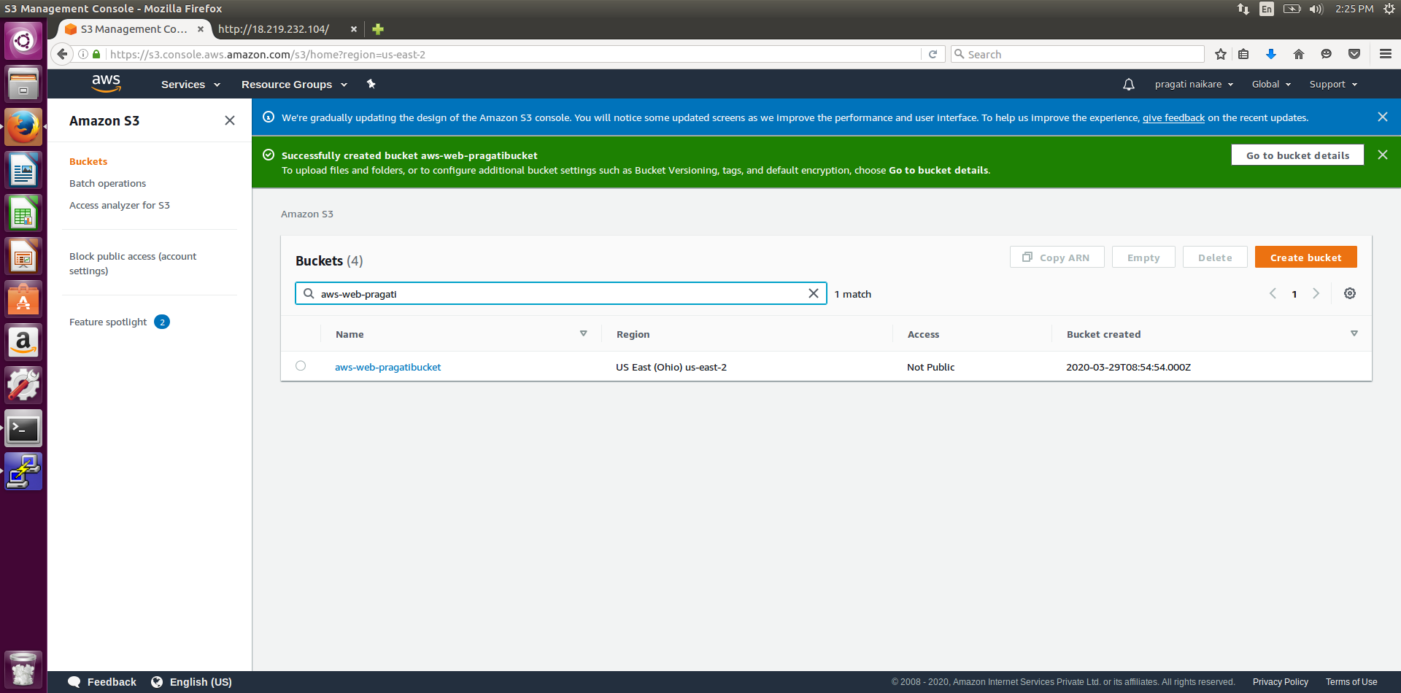

**3.2 Uploading an Object**

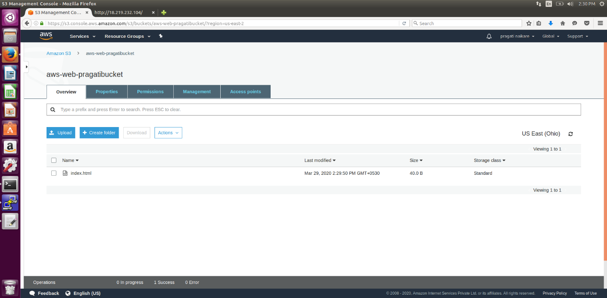

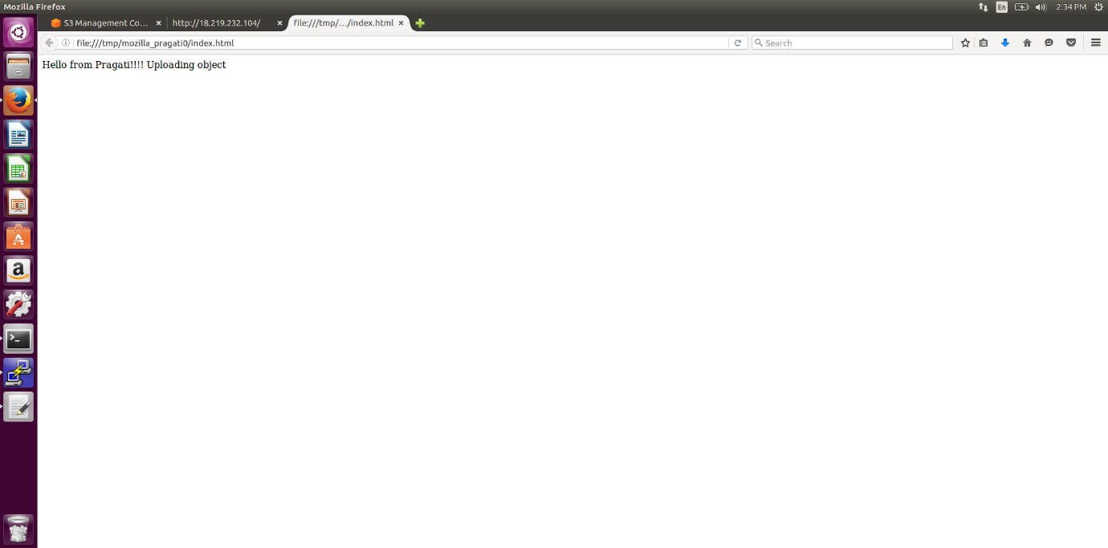

**3.3 Enabling Static Website**

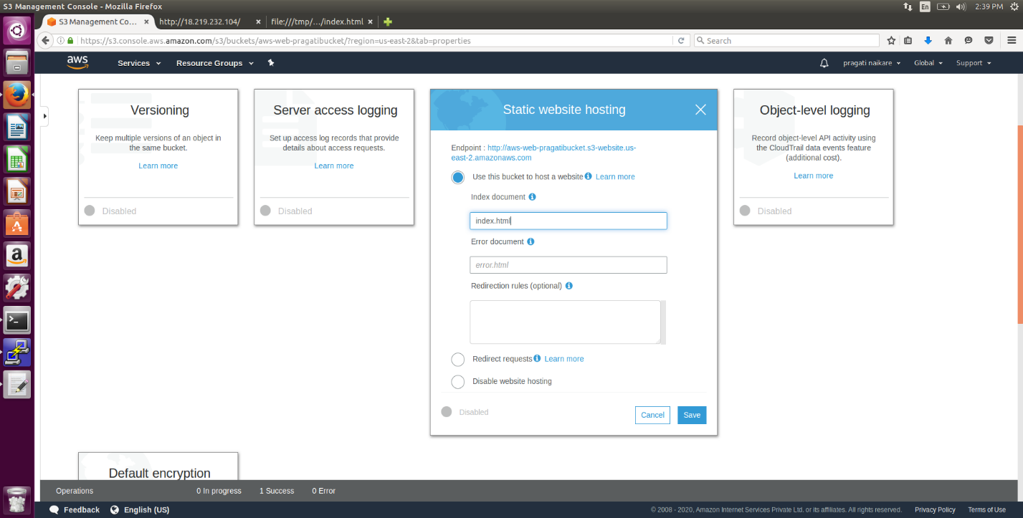

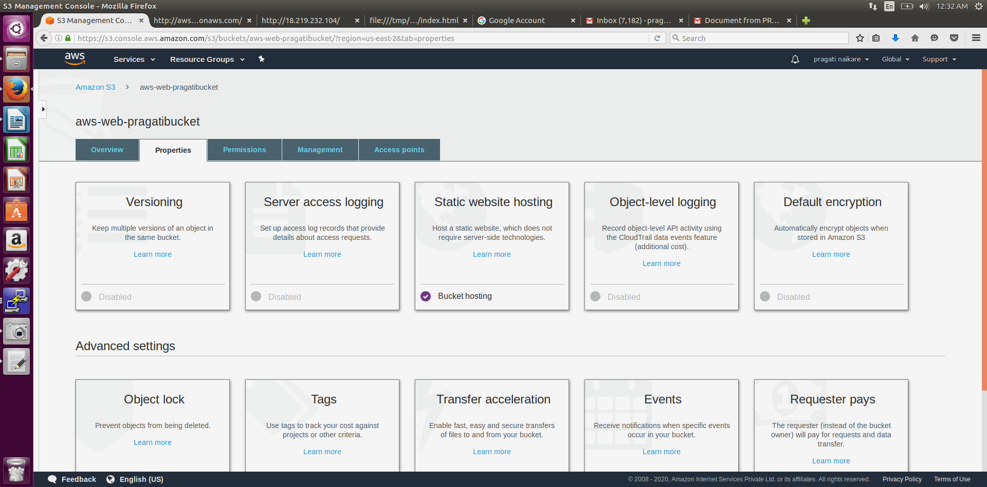

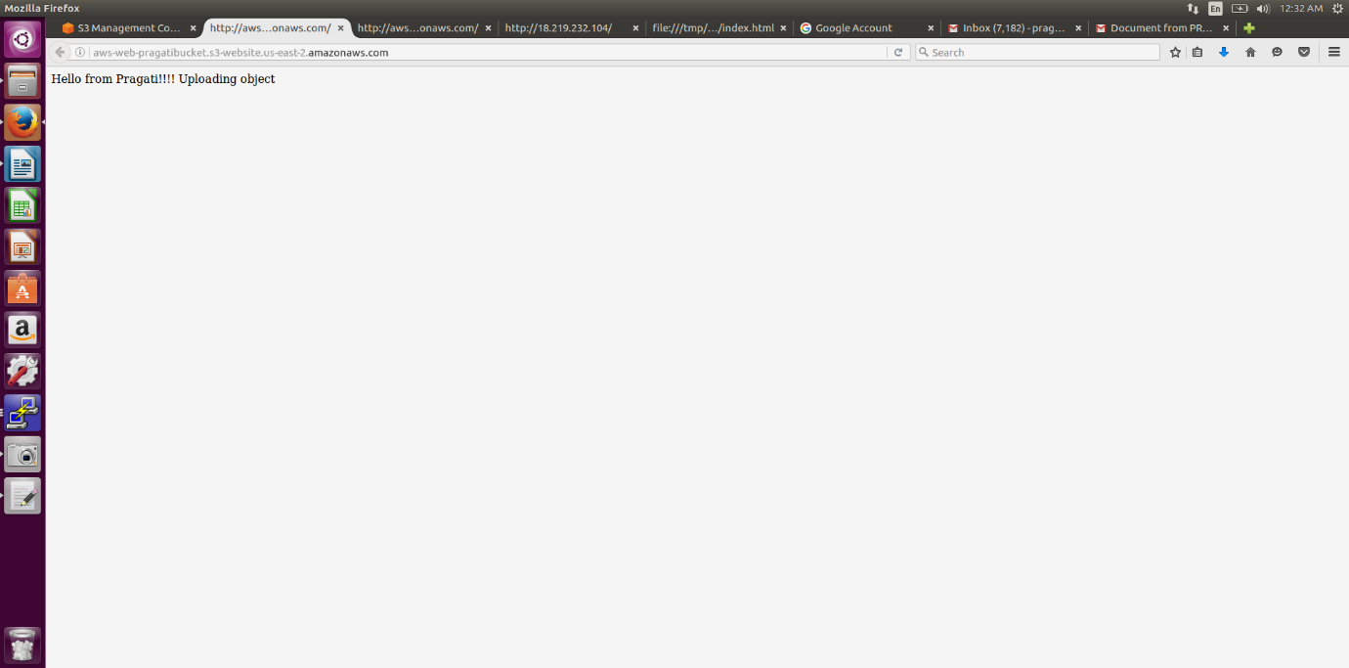

**3.4 Making The Object Public**

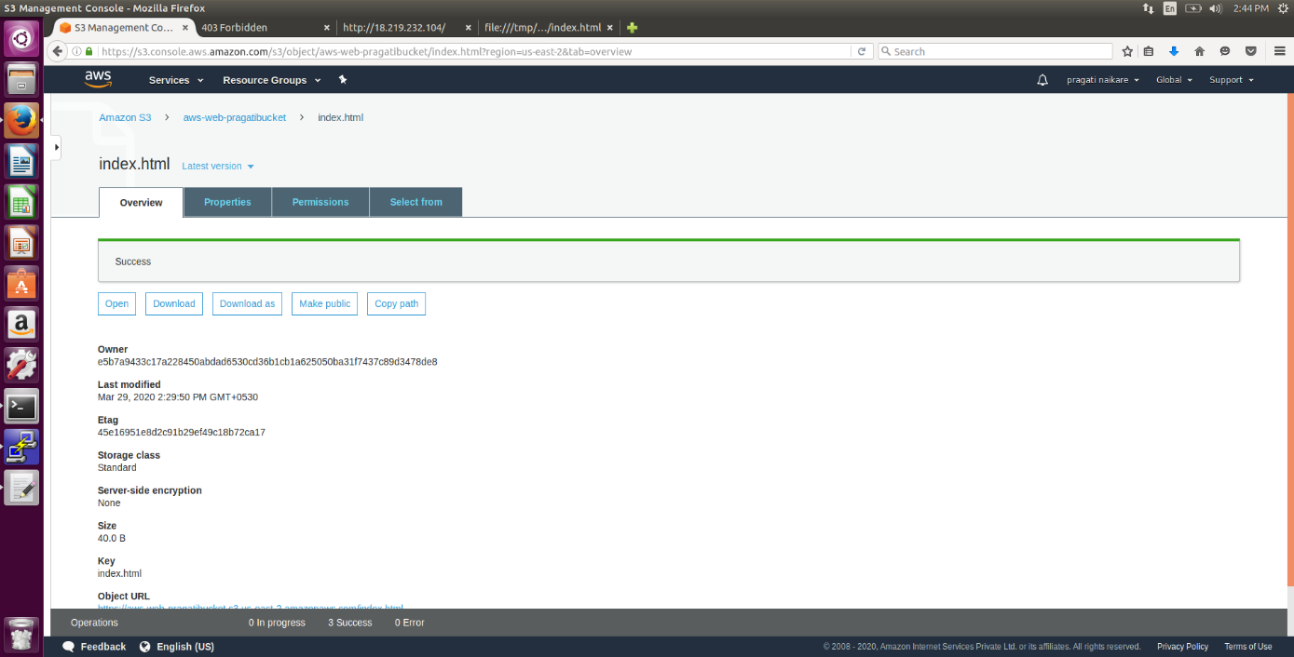

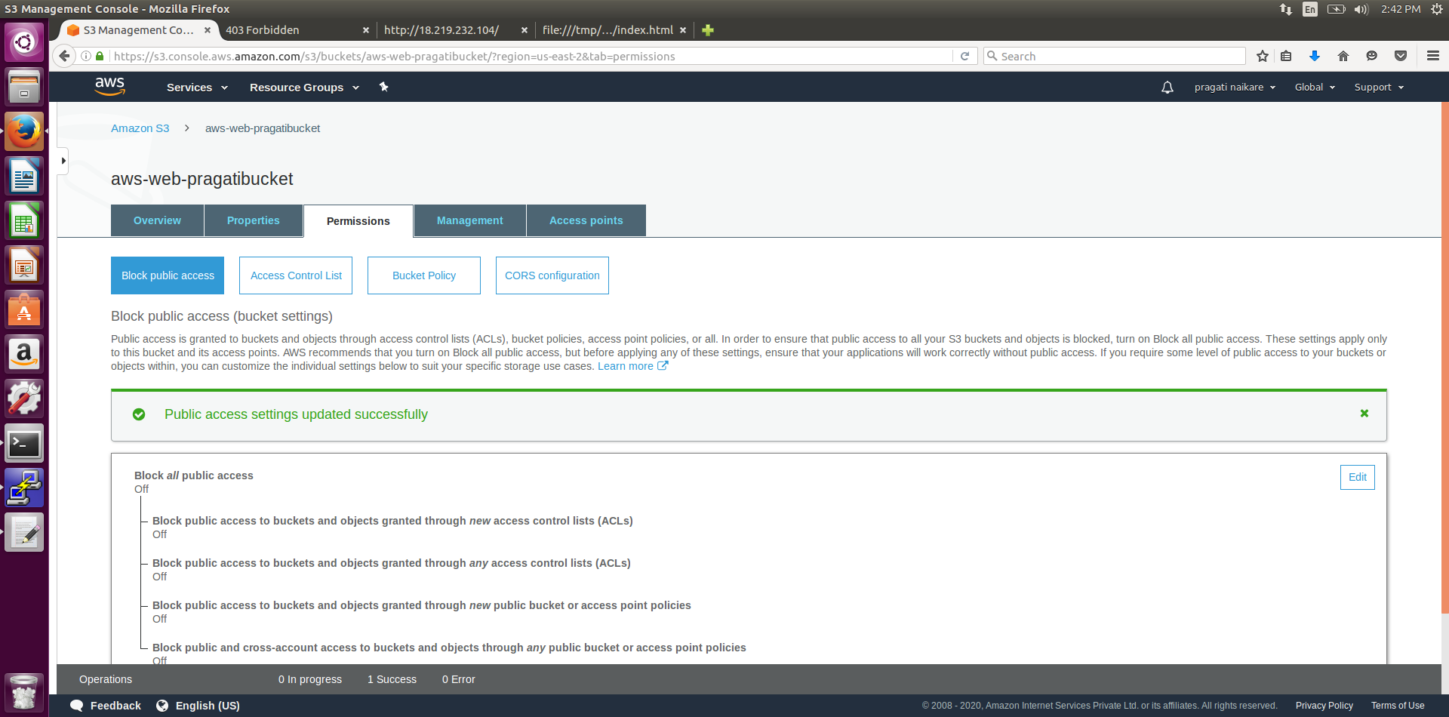

**3.5 Checking The S3 link On browser**

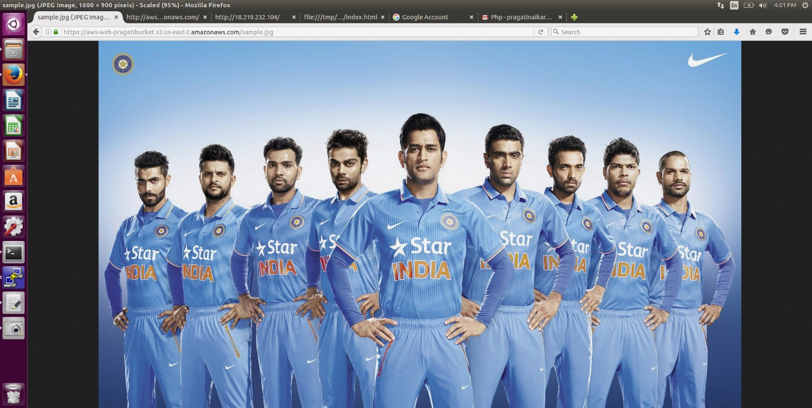

**4. Rekognition**

**4.1 Face Detect**

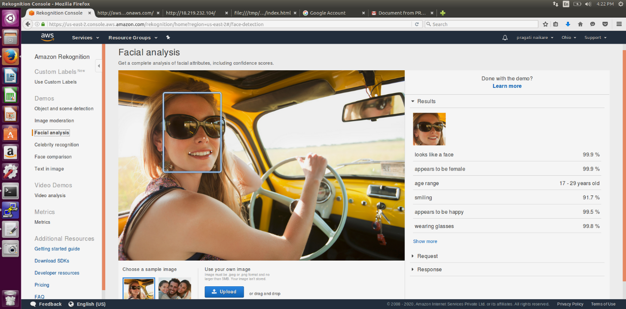

**4.2 Face Compare**

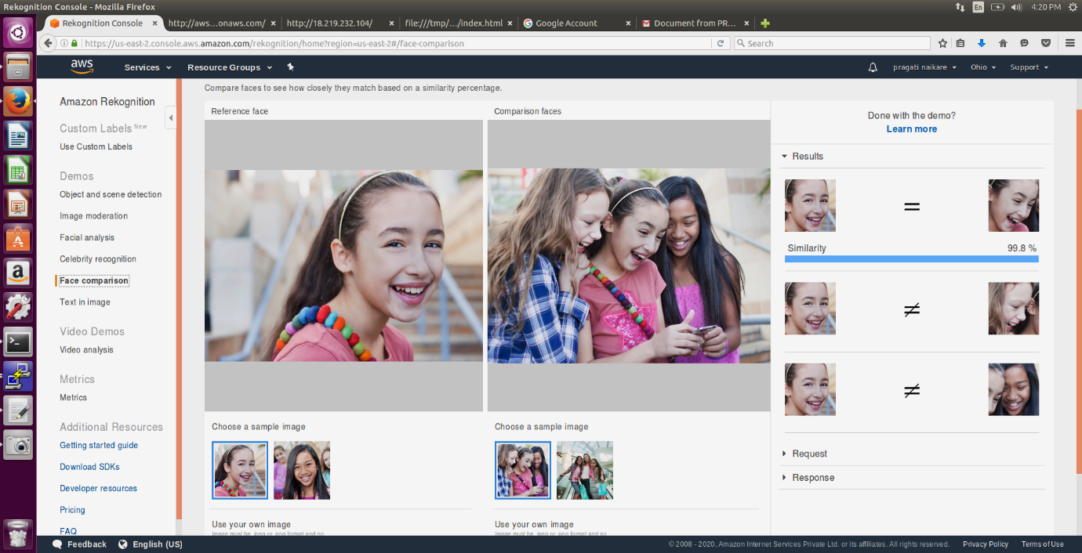

**4.3 Celebrity Rekognition**

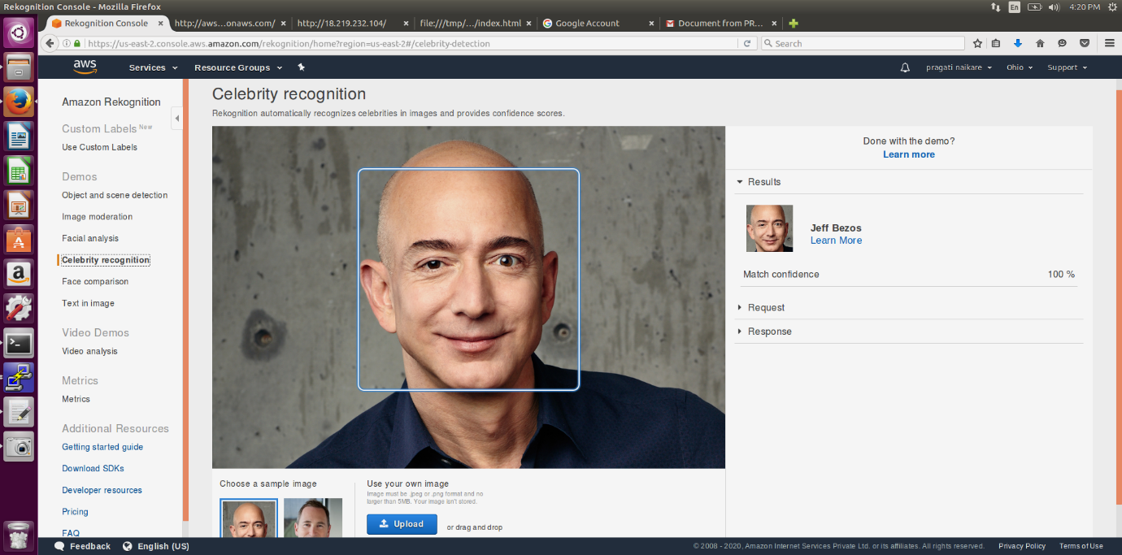

**4.4 Text In Image**

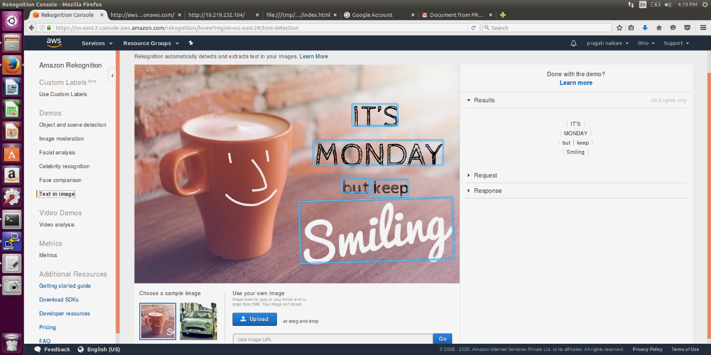

**5 . EC2 AND S3**

**5.1 Installing Aws-sdk**

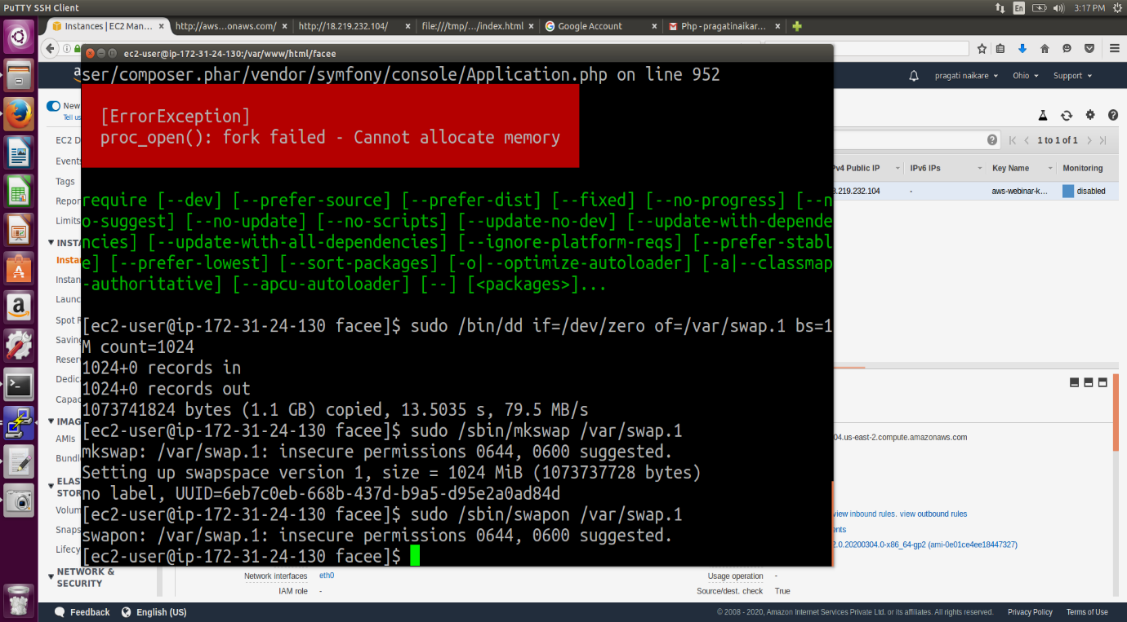

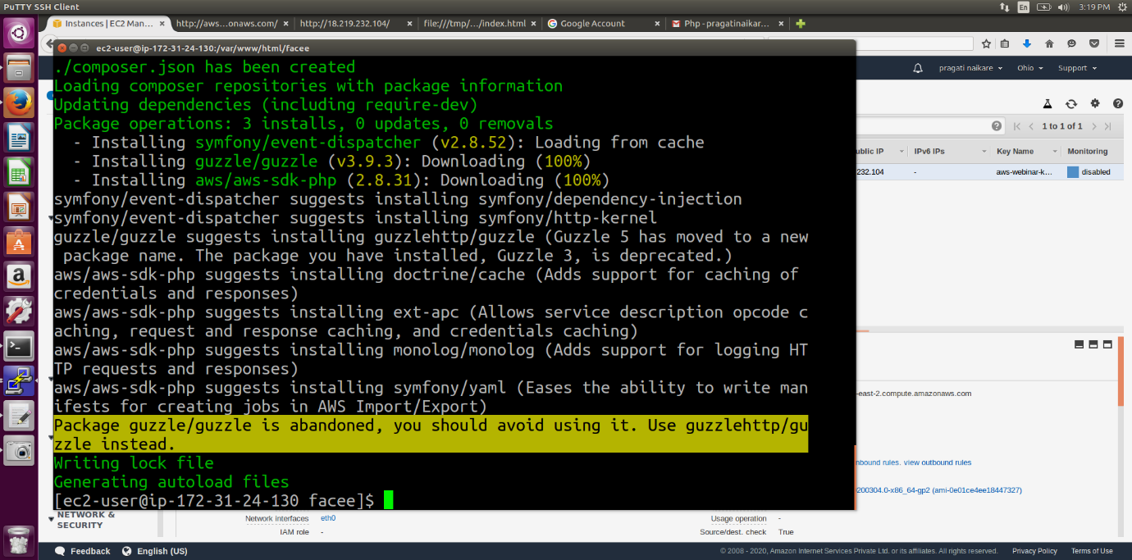

**5.2 Installing php**

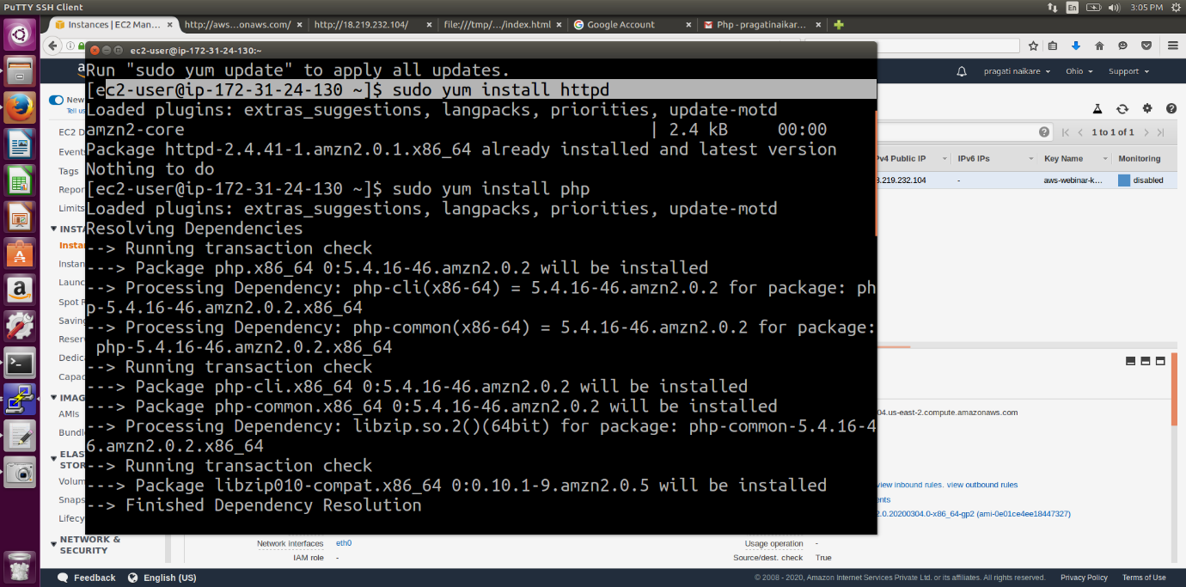

**5.3 index.php file code**

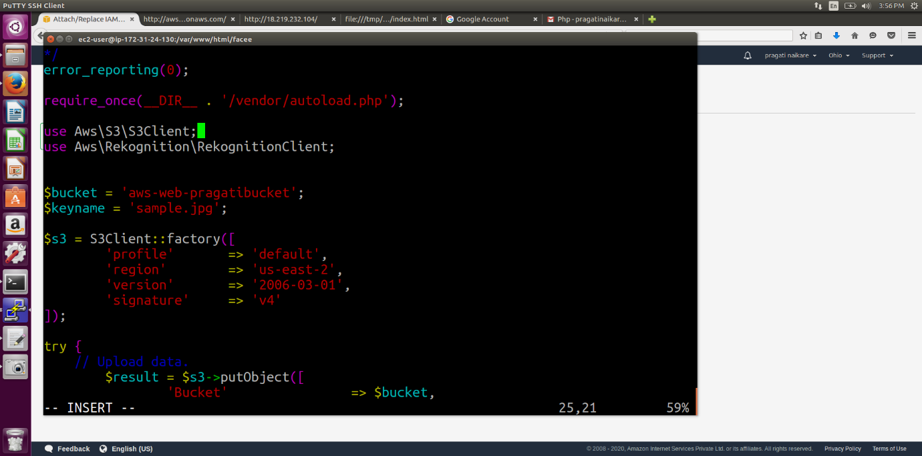

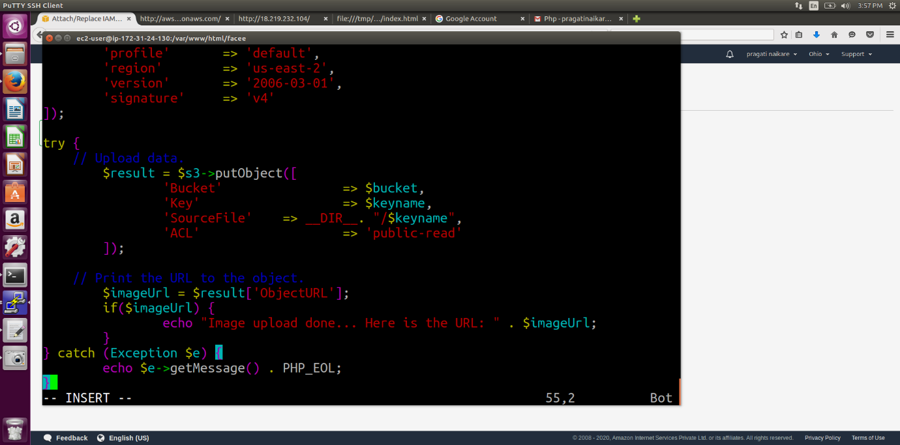

**5.4 Uploaded Success Screenshot**

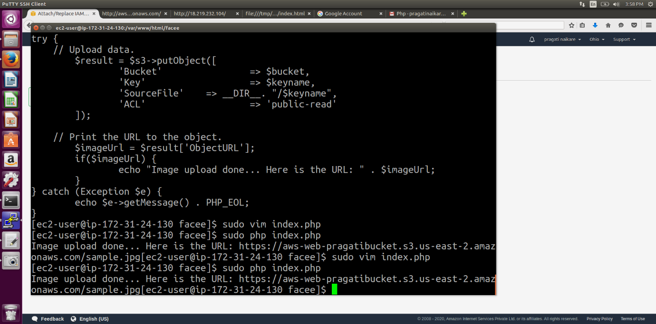

**6. EC2 & Rekognition**

**6.1 Face Detect success screenshot**

